Component | Score | Point
Follows the set-up above  Intro/Problem , Hypothesis, Abstract on Left  Title, Materials, Procedures, and Results In Center  Discussion on right (Results may also go on the right ) |  | 2  2  2
Images/graphs labelled with appropriate descriptions  (a judge should be able to read your board and know what the graph/image is for without asking you) |  | 2
Poster is neatly and carefully created |  | 5
Easy to read and understand |  | 2
Must be a 36” x 48” tri-board or larger |  | 5
TOTAL |  | 20
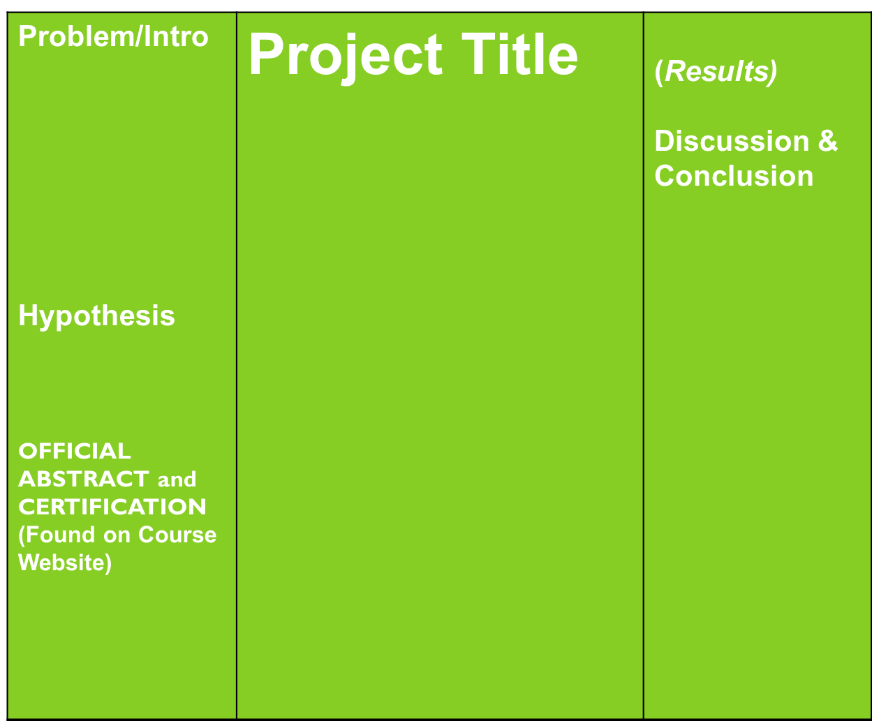
POSTER BOARD GRADING RUBRIC
Materials
Procedure
Data/Results

