SCIENCE FAIR UNIT: Table of Contents/Grade Breakdown
Experimental Method in Bold, Engineering in Italics
Scientific Method | Task  (Individually required/graded tasks are shaded in) | Point Value | Dead-line
Ask Question  Define Problem | Brain storming Session |  | Wk 2
 | Research Team (Entire Class) Goal Chosen  All Projects will be centered around this broader topic |  | Wk 2
 | Form Project Team (2-3 classmates of similar interests/skills) |  | Wk 7
 | Independent Researchers (students who wish to do a non-related topic) |  | Wk 7
Preparation  “Background Research”  Research Plan  Project Approval Process | ISEF FORM 1A: Research Plan “Project Proposal and Experimental Design” (20% of paper) |  | Wk10
 | ᶧISEF FORM 1A: Student Checklist |  | Wk10
 | ISEF FORM 1: Checklist for Adult Sponsor |  | Wk11
 | Additional ISEF Forms: 2-4 are dependent on experiment |  | Wk12
 | ISEF FORM 1B: Approval Form |  | Wk13
 | ᶧBackground Research Paper | 50 | Wk15
Construct Hypothesis  Specify Requirements | Hypothesis Rough Draft (10% of paper)  “Project Proposals” |  | Wk15
Trouble-shoot Procedure  Choose Solution/  Develop Prototype | Perform Procedure
Adjust parameters, experiment, correct variables, etc.
(Repeat as necessary)
 | Perform Final Procedure
Analyze Data  Test Solution | Data/Data-Analysis/Conclusions (20% of paper)
Communicate Results  This is done throughout.  Done for the purpose of Peer-Review | Science Fair Notebook (1 per Project Team) | 50
 | Title Page | 5
 | Results Paper (Data/Data Analysis/Conclusions/Discussion) | 50 | Wk16
 | ISEF FORM 1C: Qualified Scientist evaluation of student. |  | Wk16
 | Science Fair Board | 20 | Wk17
 | ISEF FORM: Abstract (included with board) | 20 | Wk17
 | ᶧPeer review (throughout), Discussion groups, pre-grading,
 | Derousie Science Fair | 100 | Wk17
 | RHS Science Fair (3rd Quarter)-Participation | *30
 | Clay County Science Fair (3rd Quarter)-Participation | *35
 | State Science Fair (4th Quarter) -Participation | *35
 | International Science Fair (4th Quarter) -Participation | *50
 | International Science Fair (4th Quarter) –Placing 1st-3rd | *150
ᶧIndividual Grade, *Possible Bonus Points
Term Paper Components in gray.
Deadlines are on the Friday of the assigned week.
Students are encouraged to work ahead; since if they only finished items by the deadline they will only have 2 weeks to perform their experiments (Thanksgiving break and week #16)
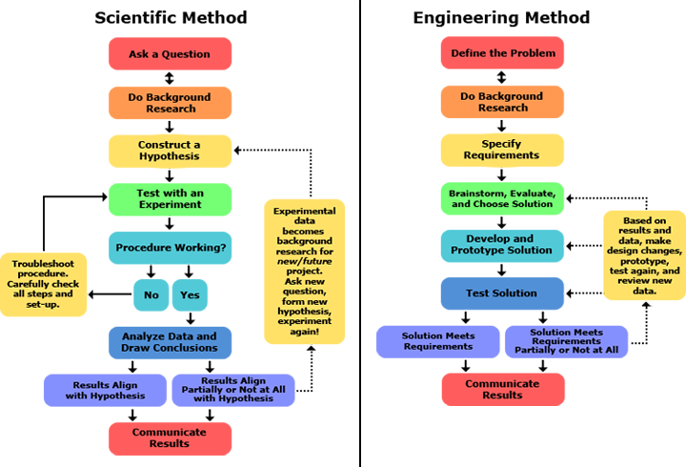
NOTE: Have these Taped to front of Science Fair notebook for appropriate projects
http://3.bp.blogspot.com/-8F4aV3CoFDY/UFTFABpK3BI/AAAAAAAAATA/o0sxq3W1sIA/s1600/seps+in+scientific-method+-+Copy.png

